2019

Coding Guidelines
Microsoft Visual C# Development best patterns and practices

José Carlos de Jesus Junior
Senior Software Architect
Last revision: 10/10/2017

Acknowledgement

Hi, my name is Jose Carlos de Jesus Junior (Technology Architect / Software Developer), and I am the author of this coding guideline document. I’ve being doing my best to review this document on a regular basis so as to keep it up with the cutting-edge technologies and agile processes.

Some chapters derive from several Microsoft product teams’ coding standards. I appreciate their sharing.

The coding standards are continuously evolving. If you discover a new best practice or a topic that is not covered, please bring that to the attention of the development team leader (juninho_web@hotmail.com). I look forward to appreciating your contributions. ☺

Disclaimer

This coding-standard document is provided "AS IS" without warranty of any kind, either expressed or implied, including but not limited to the implied warranties of merchantability and/or fitness for a particular purpose.

Please feel free to use the coding standards when you are writing VC++/VC#/VB.NET code. It would be nice, however, if you could inform us that you are using the document, or send us your feedback. You may contact us at our email address: juninho_web@hotmail.com.

Index

1. Overview 6
1.1. Principles & Themes 7
1.2. Terminology 7
2. Environment Setup 9
2.1. Productivity Power Tools 12
2.2. Magical C# Debugging – OzCode [This extension is no longer free ☹] 12
2.3. Config Transformation – Web.Config or App.Config 12
3. General Coding Standards 13
3.1. Clarity and Consistency 13
3.2. Formatting and Style 13
3.3. Using Libraries 16
3.4. Global Variables 16
3.5. Variable Declarations and Initalizations 16
3.6. Function Declarations and Calls 17
3.7. Statements 17
3.8. Enums 17
3.9. Flag Enums 19
3.10. Whitespace 20
3.11. Blank Lines 20
3.12. Spaces 21
3.13. Braces 21
3.14. Comments 21
3.15. Inline Code Comments 22
3.16. File Header Comments 24
3.17. Class Comments 25
3.18. Function Comments 25
3.19. Commenting Out Code 27
3.20. TODO Comments 27
3.21. Regions 27
4. .NET Coding Standards 28
4.1. Design Guidelines for Developing Class Libraries 28
4.2. Files and Structure 28
4.3. Assembly Properties 28
4.4. Naming Convensions 28
4.4.1. General Naming Conventions 28
4.4.2. Capitalization Naming Rules for Identifiers 29
• Pascal Case 29
• Camel Case 29
• Upper Case 29
4.5. UI Control Naming Conventions 29
4.6. Hungarian Notation 30
4.7. Constants 30
4.8. Strings 30
4.9. Arrays and Collections 31
4.10. Structures 32
4.11. Structures vs. Classes 32
4.12. Classes 32
4.13. Fields 33
4.14. Properties 33
4.15. Constructors 33
4.16. Methods 33
4.17. Events 33
4.18. Member Overloading 34
4.19. Interface Members 34
4.20. Virtual Members 34
4.21. Static Classes 34
4.22. Abstract Classes 35
4.23. Namespaces 35
4.24. Fully Qualified Name 35
4.25. TODO 35
4.26. Boxing 35
4.27. Errors and Exceptions 36
4.27.1. Exception Throwing 36
4.27.2. Exception Handling 36
4.28. Resource Cleanup 37
4.29. Try-finally Block 37
4.30. IDisposable Interface 38
4.31. Basic Dispose Pattern 38
4.32. Finalizable Types | Destructor 41
4.33. Overriding Dispose 43
4.34. Interop 44
4.34.1. P/Invoke 44
4.35. COM Interop 46
4.36. Abbreviation 46
5. .NET Coding Standards 47
• Framework.Cache 47
• Framework.Core 47
• Framework.Cryptography 47
• Framework.Data 47
• Framework.Data.SQL 47
• Framework.Dynamic 47
• Framework.Entity 47
• Framework.FTP 47
• Framework.Impersonation 47
• Framework.IO 47
• Framework.Logging 47
• Framework.MQ.IBM 47
• Framework.Office 47
• Framework.SFTP 47
• Framework.Web.Forms 47
• Framework.Web.MVC 47
• Framework.WebAPI.Cache 47
• Framework.WebAPI.CrossClient 47
• Framework.Windows.Forms 47
6. Framework Architecture 48
• BES - Business Entity Structure (MODEL !!!) 48
• BLL - Business Logic Layer 48
• DAL - Data Access Layer 48
Extensions Methods 48
7. API Integration process 49
• Punchout Setup Request 49
• Custom Token-Based Authentication and Authorization using WebAPI 49
8. Framework Sample 50
Framework.Data 50
9. Framework – Web.Config/App.Config Setup 52
10. Framework Data Profiler 52
Debug / Release 52
11. MARS – Multiple Active Result Sets 53
12. Table-Valued Parameters 54
13. Switch among environments 55
14. XML in SQL Server 2000/2005 55
15. Solid 56
• Single Responsibility Principle 56
• Open Closed Principle 56
• Liskov Substitution Principle 56
• Interface Segregation Principle 56
• Dependency Inversion Principle 56
16. Web.Config with ProtectedConfigurationProvider 57
17. SOLID - Dependency Injection 58
18. Recomendations 59
References 59

- Overview
The purpose of this document is providing a complete guideline to help developers throughout the .NET development. It standardizes the coding standards, software optimization and usage, and ensure that the best patterns and practices are put in place when it comes to .NET development.
The main reason for using a consistent set of coding conventions is to standardize the structure and coding style so that you and others can easily read and understand the code.
Good coding conventions result in precise, readable, and unambiguous source code that is consistent with other language conventions and as intuitive as possible.
No set of guidelines will satisfy everyone. The goal of a standard is to create efficiencies across a community of developers. Applying a set of well-defined coding standards will result in code with fewer bugs, and better maintainability. Adopting an unfamiliar standard may be awkward initially, but the pain fades quickly and the benefits are quickly realized, especially when you inherit ownership of others' code.

  - Principles & Themes
High-quality samples exhibit the following characteristics because customers use them as examples of best practices:

- Understandable. Samples must be clearly readable and straightforward. They must showcase the key things they’re designed to demonstrate. The relevant parts of a sample should be easy to reuse. Samples should not contain unnecessary code. They must include appropriate documentation.
- Correct. Samples must demonstrate properly how to perform the key things they are designed to teach. They must compile cleanly, run correctly as documented, and be tested.
- Consistent. Samples should follow consistent coding style and layout to make the code easier to read. Likewise, samples should be consistent with each other to make them easier to use together. Consistency shows craftsmanship and attention to detail.
- Modern. Samples should demonstrate current practices such as use of Unicode, error handling, defensive programming, and portability. They should use current recommendations for runtime library and API functions. They should use recommended project & build settings.
- Safe. Samples must comply with legal, privacy, and policy standards. They must not demonstrate hacks or poor programming practices. They must not permanently alter machine state. All installation and execution steps must be reversible.
- Secure. The samples should demonstrate how to use secure programming practices such as least privilege, secure versions of runtime library functions, and SDL-recommended project settings.
The proper use of programming practices, design, and language features determines how well samples can achieve these. This code standard is designed to help you create samples that serve as “best practices” for customers to emulate.
  - Terminology
Throughout this document there will be recommendations or suggestions for standards and practices. Some practices are very important and must be followed, others are guidelines that are beneficial in certain scenarios but are not applicable everywhere. In order to clearly state the intent of the standards and practices that are discussed we will use the following terminology.

Wording | Intent | Justification
☑ Do... | This standard or practice should be followed in all cases. If you think that your specific application is exempt, it probably isn't. | These standards are present to mitigate bugs.
☒ Do Not... | This standard or practice should never be applied. | These standards are present to mitigate bugs.
☑ You should... | This standard or practice should be followed in most cases. | These standards are typically stylistic and attempt to promote a consistent and clear style.
☒ You should not... | This standard or practice should not be followed, unless there's reasonable justification.
☑ You can… | This standard or practice can be followed if you want to; it's not necessarily good or bad. There are probably implications to following the practice (dependencies, or constraints) that should be considered before adopting it. | These standards are typically stylistic, but are not ubiquitously adopted.

Environment Setup
Microsoft Visual Studio 2017 Enterprise Edition is a must-have software for the development team and must be installed prior to start any development. The latest Visual Studio’s Service Packs must be installed as well.
After installed, you will need to setup your Visual Studio environment to follow the current standards like tabulation, and indentation definitions that is described below in this document. To start, please reset your Visual Studio environment as described below.
Plus, I recommend you to install Visual Studio Code along with Visual Studio for web development, so you can create robust web application based on non-Microsoft stack technologies such Angular/Typescript and hook them up through an ASP.NET Core Web API, for example.
Reset
Go to Tools > Import and Export Settings and choose the “Reset All Settings”
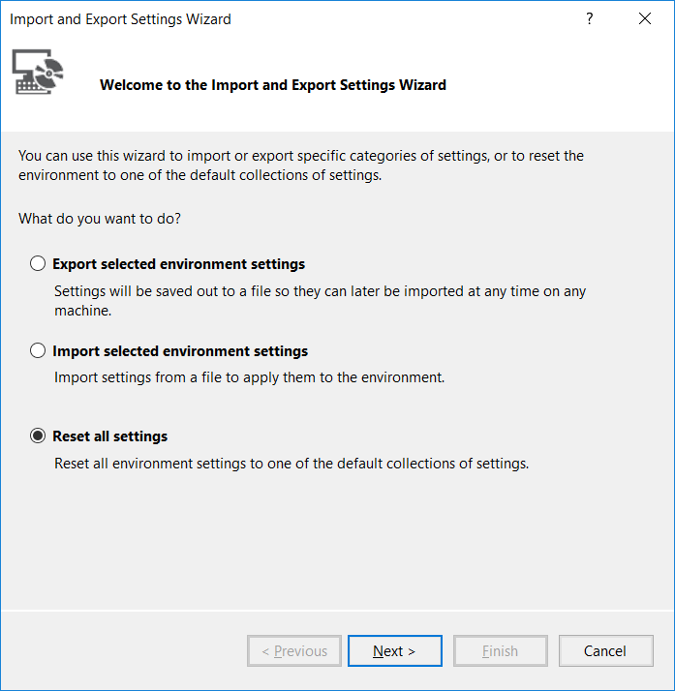
Check the option “No, just reset settings, overwriting my current settings”
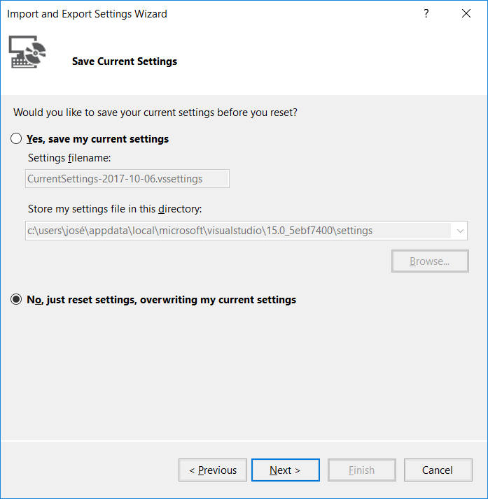

In the next screen, select the “Visual C#” item
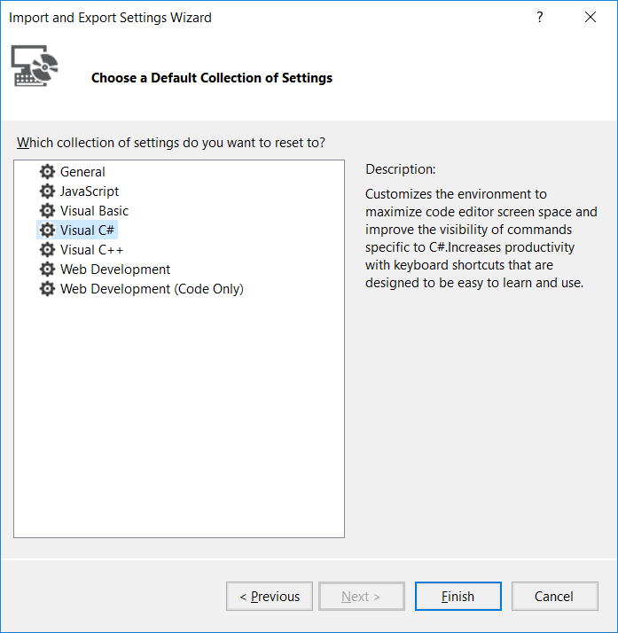
  - Productivity Power Tools
Install the Microsoft Visual Studio 2017 Productivity Power Tools through the “Extensions and Updates” menu, or download it directly from the link:
https://marketplace.visualstudio.com/items?itemName=VisualStudioProductTeam.ProductivityPowerPack2017
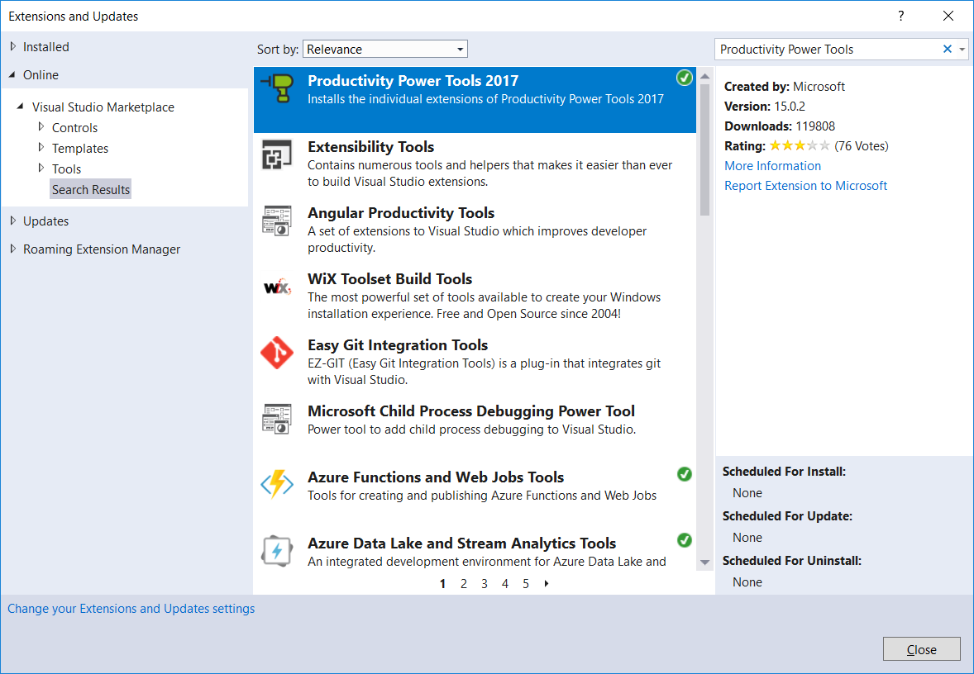
  - Magical C# Debugging – OzCode [This extension is no longer free ☹]
Install the Magical C# Debugging - OzCode through the “Extensions and Updates” menu, or download it directly from the link: https://marketplace.visualstudio.com/items?itemName=CodeValueLtd.OzCode
  - Config Transformation – Web.Config or App.Config
Automatically transform app.config or any other config during build process. Once the transformation is set, it will run on other build machines without the extension.
Install the 2.3. Config Transformation through the “Extensions and Updates” menu, or download it directly from the link: https://marketplace.visualstudio.com/items?itemName=GolanAvraham.ConfigurationTransform

General Coding Standards

These general coding standards can be applied to all languages - they provide high-level guidance to the style, formatting and structure of your source code.
  - Clarity and Consistency
☑ Do ensure that clarity, readability and transparency are paramount. These coding standards strive to ensure that the resultant code is easy to understand and maintain, but nothing beats fundamentally clear, concise, self-documenting code.

☑ Do ensure that when applying these coding standards that they are applied consistently.
  - Formatting and Style
☒ Do not use tabs. It's generally accepted across Microsoft that tabs shouldn't be used in source files - different text editors use different spacing to render tabs, and this causes formatting confusion. All code should be written using four spaces for indentation.

Visual Studio text editor can be configured to insert spaces for tabs.
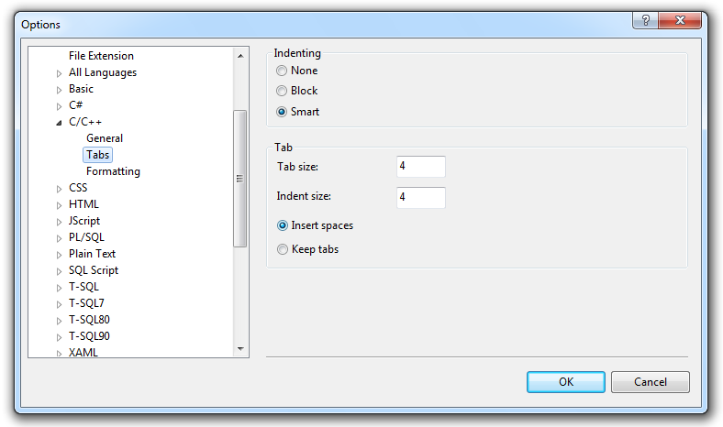
☑ Do use a fixed-width font, typically Courier New, in your code editor.
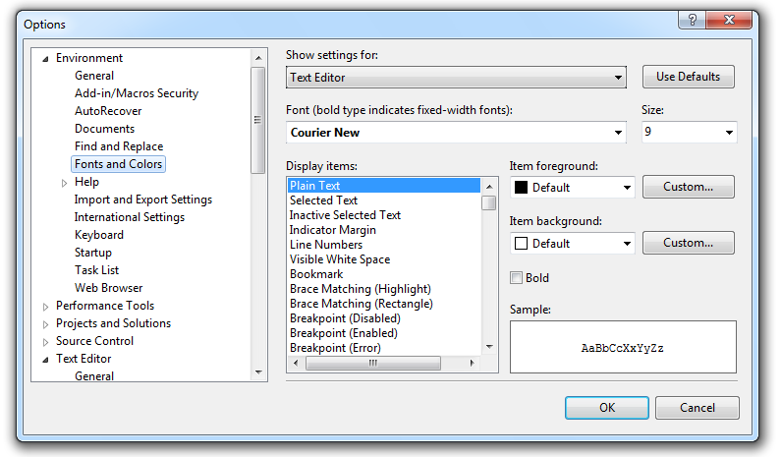
JavaScript Indentation
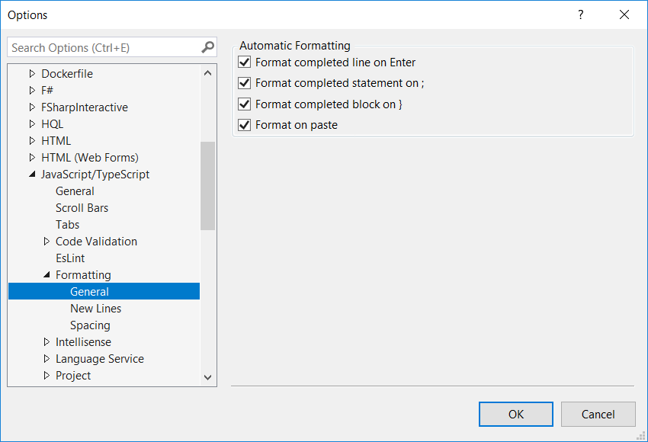
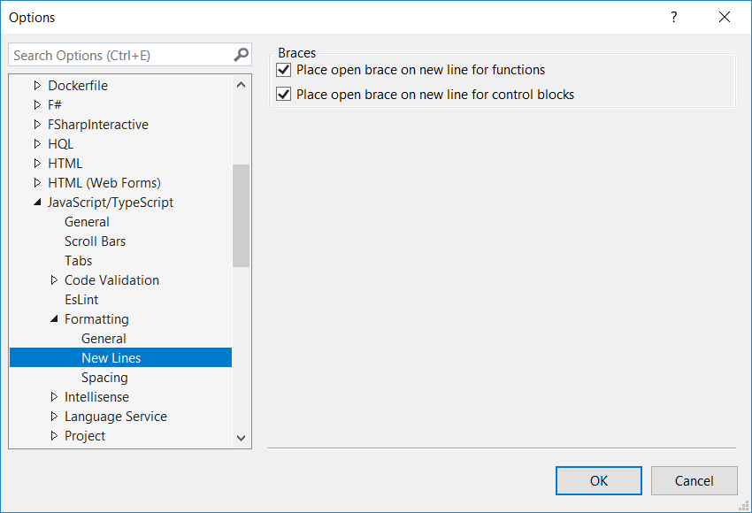
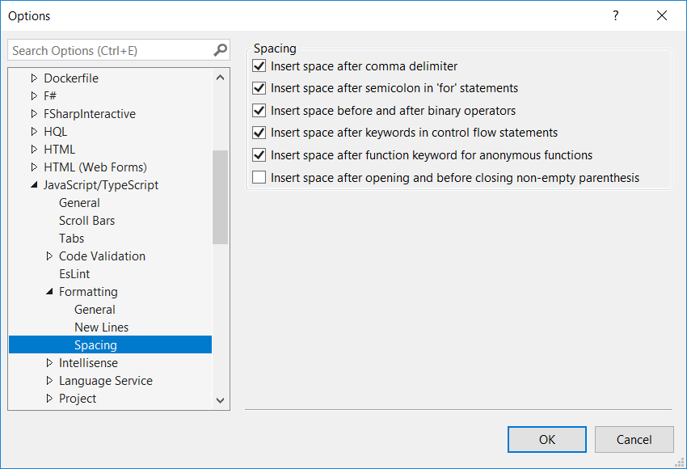
Example:
<script type="text/javascript">
☒ // Before the definitions
this.SayHello = function (name) {
if (name == "Hello") {
alert('OK');
}
}

☑ // After adjusting the settings
this.MyMethod = function(name)
{
if (name == "Hello")
{
alert('OK');
}
}
</script>
  - Using Libraries
☒ Do not reference unnecessary libraries, include unnecessary header files, or reference unnecessary assemblies. Paying attention to small things like this can improve build times, minimize chances for mistakes, and give readers a good impression.
  - Global Variables
☑ Do minimize global variables. To use global variables properly, always pass them to functions through parameter values. Never reference them inside of functions or classes directly because doing so creates a side effect that alters the state of the global without the caller knowing. The same goes for static variables. If you need to modify a global variable, you should do so either as an output parameter or return a copy of the global.
  - Variable Declarations and Initalizations
☑ Do declare local variables in the minimum scope block that can contain them, typically just before use if the language allows; otherwise, at the top of that scope block.

☑ Do initialize variables when they are declared.

☑ Do declare and initialize/assign local variables on a single line where the language allows it. This reduces vertical space and makes sure that a variable does not exist in an un-initialized state or in a state that will immediately change.

// C# sample:
string name = myObject.Name;
int val = time.Hours;

☒ Do not declare multiple variables in a single line. One declaration per line is recommended since it encourages commenting, and could avoid confusion. As a Visual C++ example,

☑ Good int firstItem; // comment for the item1 int secondItem; // comment for the item2 | ☒ Bad  int firstItem, secondItem;

  - Function Declarations and Calls
The function/method name, return value and parameter list can take several forms. Ideally this can all fit on a single line. If there are many arguments that don't fit on a line those can be wrapped, many per line or one per line. Put the return type on the same line as the function/method name. For example,

Single Line Format:

// C++ function declaration sample:
HRESULT DoSomeFunctionCall(int param1, int param2, int *param3);

// C++ / C# function call sample:
hr = DoSomeFunctionCall(param1, param2, param3);

Multiple Line Formats:

When breaking up the parameter list into multiple lines, each type/parameter pair should line up under the preceding one, the first one being on a new line, indented one tab. Parameter lists for function/method calls should be formatted in the same manner.

// C++ function declaration sample:
HRESULT DoSomeFunctionCall(
HWND hwnd, // You can comment parameters, too
T1 param1, // Indicates something
T2 param2, // Indicates something else
T3 param3, // Indicates more
T4 param4, // Indicates even more
T5 param5); // You get the idea

C# function call sample:
hr = DoSomeFunctionCall(
hwnd,
param1,
param2,
param3,
param4,
param5);

☑ Do order parameters, grouping the in parameters first, the out parameters last. Within the group, order the parameters based on what will help programmers supply the right values. For example, if a function takes arguments named “left” and “right”, put “left” before “right” so that their place match their names. When designing a series of functions which take the same arguments, use a consistent order across the functions. For example, if one function takes an input handle as the first parameter, all of the related functions should also take the same input handle as the first parameter.
  - Statements
☒ Do not put more than one statement on a single line because it makes stepping through the code in a debugger much more difficult.

☑ Good:  // C++ / C# sample:  a = 1;  b = 2; | ☒ Bad:  // C++ / C# sample:  a = 1; b = 2;
  - Enums
☑ Do use an enum to strongly type parameters, properties, and return values that represent sets of values.

☑ Do favor using an enum over static constants or “#define” values . An enum is a structure with a set of static constants. The reason to follow this guideline is because you will get some additional compiler and reflection support if you define an enum versus manually defining a structure with static constants.

☑ Good:
// C++ sample:
enum Color
{
Red,
Green,
Blue
};

// C# sample:
public enum Color
{
Red,
Green,
Blue
}

☒ Bad:
// C++ sample:
const int RED = 0;
const int GREEN = 1;
const int BLUE = 2;

#define RED 0
#define GREEN 1
#define BLUE 2

// C# sample:
public static class Color
{
public const int Red = 0;
public const int Green = 1;
public const int Blue = 2;
}

☒ Do not use an enum for open sets (such as the operating system version, names of your friends, etc.).

☑ Do provide a value of zero on simple enums. Consider calling the value something like “None.” If such value is not appropriate for this particular enum, the most common default value for the enum should be assigned the underlying value of zero.

// C++ sample:
enum Compression
{
None = 0,
GZip,
Deflate
};

// C# sample:
public enum Compression
{
None = 0,
GZip,
Deflate
}

☒ Do not use Enum.IsDefined for enum range checks in .NET. There are really two problems with Enum.IsDefined. First it loads reflection and a bunch of cold type metadata, making it a surprisingly expensive call. Second, there is a versioning issue here.

☑ Good:
// C# sample:
if (c > Color.Black || c < Color.White)
{
throw new ArgumentOutOfRangeException(...);
}

☒ Bad:
// C# sample:
if (!Enum.IsDefined(typeof(Color), c))
{
throw new InvalidEnumArgumentException(...);
}
  - Flag Enums
Flag enums are designed to support bitwise operations on the enum values. A common example of the flags enum is a list of options.

☑ Do apply the System.FlagsAttribute to flag enums in .NET. Do not apply this attribute to simple enums.

☑ Do use powers of two for the flags enum values so they can be freely combined using the bitwise OR operation. For example,

// C++ sample:
enum AttributeTargets
{
Assembly = 0x0001,
Class = 0x0002,
Struct = 0x0004
...
};

// C# sample:
[Flags]
public enum AttributeTargets
{
Assembly = 0x0001,
Class = 0x0002,
Struct = 0x0004,
...
}

☑ You should provide special enum values for commonly used combinations of flags. Bitwise operations are an advanced concept and should not be required for simple tasks. FileAccess.ReadWrite is an example of such a special value. However, you should not create flag enums where certain combinations of values are invalid.

// C++ sample:
enum FileAccess
{
Read = 0x1,
Write = 0x2,
ReadWrite = Read | Write
};

// C# sample:
[Flags]
public enum FileAccess
{
Read = 0x1,
Write = 0x2,
ReadWrite = Read | Write
}

☒ You should not use flag enum values of zero, unless the value represents “all flags are cleared” and is named appropriately as “None”. The following C# example shows a common implementation of a check that programmers use to determine if a flag is set (see the if-statement below). The check works as expected for all flag enum values except the value of zero, where the Boolean expression always evaluates to true.

☒ Bad:
[Flags]
public enum SomeFlag
{
ValueA = 0, // This might be confusing to users
ValueB = 1,
ValueC = 2,
ValueBAndC = ValueB | ValueC,
}
SomeFlag flags = GetValue();
if ((flags & SomeFlag.ValueA) == SomeFlag.ValueA)
{
...
}

☑ Good:
[Flags]
public enum BorderStyle
{
Fixed3D = 0x1,
FixedSingle = 0x2,
None = 0x0
}
if (foo.BorderStyle == BorderStyle.None)
{
...
}

  - Whitespace
  - Blank Lines
☑ You should use blank lines to separate groups of related statements. Omit extra blank lines that do not make the code easier to read. For example, you can have a blank line between variable declarations and code.

☑ Good:
// C++ sample:
void ProcessItem(const Item& item)
{
int counter = 0;

if(...)
{
}
}

☒ Bad:
// C++ sample:
void ProcessItem(const Item& item)
{
int counter = 0;

// Implementation starts here
//
if(...)
{
}

}

In this example of bad usage of blank lines, there are multiple blank lines between the local variable declarations, and multiple blank likes after the ‘if’ block.

☑ You should use two blank lines to separate method implementations and class declarations.
  - Spaces
Spaces improve readability by decreasing code density. Here are some guidelines for the use of space characters within code:

☑ You should use spaces within a line as follows.

☑ Good:
// C++ / C# sample:
CreateFoo(); // No space between function name and parenthesis
Method(myChar, 0, 1); // Single space after a comma
x = array[index]; // No spaces inside brackets
while (x == y) // Single space before flow control statements
if (x == y) // Single space separates operators

☒ Bad:
// C++ / C# sample:
CreateFoo (); // Space between function name and parenthesis
Method(myChar,0,1); // No spaces after commas
CreateFoo( myChar, 0, 1 ); // Space before first arg, after last arg
x = array[ index ]; // Spaces inside brackets
while(x == y) // No space before flow control statements
if (x==y) // No space separates operators

  - Braces
☑ Do use Allman bracing style while writing your source code.

The Allman style is named after Eric Allman. It is sometimes referred to as "ANSI style". The style puts the brace associated with a control statement on the next line, indented to the same level as the control statement. Statements within the braces are indented to the next level.

☑ Good:
// C++ / C# sample:
if (x > 5)
{
y = 0;
}

☒ Bad (aka java style):
// C++ / C# sample:
if (x > 5) {
y = 0;
}

☑ You should use braces around single line conditionals. Doing this makes it easier to add code to these conditionals in the future and avoids ambiguities should the tabbing of the file become disturbed.

☑ Good:
// C++ / C# sample:
if (x > 5)
{
y = 0;
}

☒ Bad:
// C++ / C# sample:
if (x > 5) y = 0;

  - Comments
You are required to comment every namespaces, classes, methods and properties in order to generate the source code documentation automatically by using SandCastle or NDOC.
Methods:
/// <summary>
/// This method downloads a FTP file specified by FtpPath and saves it to FilePath.
/// Throws a WebException on encountering a network error.
/// </summary>
public void DownloadFile(string FtpPath, string FilePath){…}
Properties:
/// <summary>
/// SQL Server connection to the underlying database
/// </summary>
public SqlConnection Connection { get; set; }
☑ You should use comments that summarize what a piece of code is designed to do and why. Do not use comments to repeat the code.
☑ Good:
// Determine whether system is running Windows Vista or later operating
// systems (major version >= 6) because they support linked tokens, but
// previous versions (major version < 6) do not.

☒ Bad:
// The following code sets the variable i to the starting value of the
// array. Then it loops through each item in the array.

☑ You should use ‘//’ comments instead of ‘/* */’ for comments for C++ and C# code comments. The single-line syntax (// …) is preferred even when a comment spans multiple lines.

// Determine whether system is running Windows Vista or later operating
// systems (major version >= 6) because they support linked tokens, but
// previous versions (major version < 6) do not.
if (Environment.OSVersion.Version.Major >= 6)
{

}

☑ You should indent comments at the same level as the code they describe.
☑ You should use full sentences with initial caps, a terminating period and proper punctuation and spelling in comments.

☑ Good:
// Intialize the components on the Windows Form.
InitializeComponent();

☒ Bad:
//intialize the components on the Windows Form.
InitializeComponent();
  - Inline Code Comments
Inline comments should be included on their own line and should be indented at the same level as the code they are commenting on, with a blank line before, but none after. Comments describing a block of code should appear on a line by themselves, indented as the code they describe, with one blank line before it and one blank line after it. For example:

if (MAXVAL >= exampleLength)
{
// Reprort the error.
ReportError(GetLastError());

// The value is out of range, we cannot continue.
return E_INVALIDARG;
}

Inline comments are permissible on the same line as the actual code only when giving a brief description of a structure member, class member variable, parameter, or a short statement. In this case it is a good idea to align the comments for all variables. For example:

class Example
{
public:
...

void TestFunction
{
...
do
{
...
}
while (!fFinished); // Continue if not finished.
}

private:
int m_length; // The length of the example
float m_accuracy; // The accuracy of the example
};

☒ You should not drown your code in comments. Commenting every line with obvious descriptions of what the code does actually hinders readability and comprehension. Single-line comments should be used when the code is doing something that might not be immediately obvious.

The following example contains many unnecessary comments:

☒ Bad:
// Loop through each item in the wrinkles array
for (int i = 0; i <= nLastWrinkle; i++)
{
Wrinkle *pWrinkle = apWrinkles[i]; // Get the next wrinkle
if (pWrinkle->IsNew() && // Process if it’s a new wrinkle
nMaxImpact < pWrinkle->GetImpact()) // And it has the biggest impact
{
nMaxImpact = pWrinkle->GetImpact(); // Save its impact for comparison
pBestWrinkle = pWrinkle; // Remember this wrinkle as well
}
}
A better implementation would be:

☑ Good:
// Loop through each item in the wrinkles array, find the Wrinkle with
// the largest impact that is new, and store it in ‘pBestWrinkle’.
for (int i = 0; i <= nLastWrinkle; i++)
{
Wrinkle *pWrinkle = apWrinkles[i];
if (pWrinkle->IsNew() && nMaxImpact < pWrinkle->GetImpact())
{
nMaxImpact = pWrinkle->GetImpact();
pBestWrinkle = pWrinkle;
}
}

☑ You should add comments to call out non-intuitive or behavior that is not obvious from reading the code.

  - File Header Comments
☑ Do have a file header comment at the start of every human-created code file. The header comment templates are as follows:

VC++ and VC# file header comment template:

/****************************** Module Header ******************************\
Module Name: <File Name>
Project: <Sample Name>
Copyright (c) Microsoft Corporation.

<Description of the file>

This source is subject to the Microsoft Public License.
See http://www.microsoft.com/opensource/licenses.mspx#Ms-PL.
All other rights reserved.

THIS CODE AND INFORMATION IS PROVIDED "AS IS" WITHOUT WARRANTY OF ANY KIND,
EITHER EXPRESSED OR IMPLIED, INCLUDING BUT NOT LIMITED TO THE IMPLIED
WARRANTIES OF MERCHANTABILITY AND/OR FITNESS FOR A PARTICULAR PURPOSE.
\***************************************************************************/

For example,

/****************************** Module Header ******************************\
Module Name: CppUACSelfElevation.cpp
Project: CppUACSelfElevation
Copyright (c) Microsoft Corporation.

User Account Control (UAC) is a new security component in Windows Vista and
newer operating systems. With UAC fully enabled, interactive administrators
normally run with least user privileges. This example demonstrates how to
check the privilege level of the current process, and how to self-elevate
the process by giving explicit consent with the Consent UI.

This source is subject to the Microsoft Public License.
See http://www.microsoft.com/opensource/licenses.mspx#Ms-PL.
All other rights reserved.

THIS CODE AND INFORMATION IS PROVIDED "AS IS" WITHOUT WARRANTY OF ANY KIND,
EITHER EXPRESSED OR IMPLIED, INCLUDING BUT NOT LIMITED TO THE IMPLIED
WARRANTIES OF MERCHANTABILITY AND/OR FITNESS FOR A PARTICULAR PURPOSE.
\***************************************************************************/

  - Class Comments
☑ You should provide banner comments for all classes and structures that are non-trivial. The level of commenting should be appropriate based on the audience of the code.

C++ class comment template:

//
// NAME: class <Class name>
// DESCRIPTION: <Class description>
//

C# and VB.NET use .NET descriptive XML Documentation comments. When you compile .NET projects with /doc the compiler will search for all XML tags in the source code and create an XML documentation file.

C# class comment template:

/// <summary>
/// <Class description>
/// </summary>

For example,

//
// NAME: class CodeExample
// DESCRIPTION: The CodeExample class represents an example of code, and
// tracks the length and complexity of the example.
//
class CodeExample
{
...
};

/// <summary>
/// The CodeExample class represents an example of code, and tracks
/// the length and complexity of the example.
/// </summary>
public class CodeExample
{
...
}
  - Function Comments
☑ You should provide banner comments for all public and non-public functions that are not trivial. The level of commenting should be appropriate based on the audience of the code.

C++ function comment template:

/*---------------------------------------------------------------------------
FUNCTION: <Funtion prototype>

PURPOSE:
<Function description>

PARAMETERS:
<Parameter name> –<Parameter description>

RETURN VALUE:
<Description of function return value>

EXCEPTION:
<Exception that may be thrown by the function>

EXAMPLE CALL:
<Example call of the function>

REMARKS:
<Additional remarks of the function>
---------------------------------------------------------------------------*/

C# and VB.NET use descriptive XML Documentation comments. At least a <summary> element and also a <parameters> element and <returns> element, where applicable, are required. Methods that throw exceptions should make use of the <exception> element to indicate to consumers what exceptions may be thrown.

C# function comment template:

/// <summary>
/// <Function description>
/// </summary>
/// <param name="Parameter name">
/// <Parameter description>
/// </param>
/// <returns>
/// <Description of function return value>
/// </returns>
/// <exception cref="<Exception type>">
/// <Exception that may be thrown by the function>
/// </exception>

For example,

/*---------------------------------------------------------------------------
FUNCTION: IsUserInAdminGroup(HANDLE hToken)

PURPOSE:
The function checks whether the primary access token of the process
belongs to user account that is a member of the local Administrators
group, even if it currently is not elevated.

PARAMETERS:
hToken – the handle to an access token.

RETURN VALUE:
Returns TRUE if the primary access token of the process belongs to user
account that is a member of the local Administrators group. Returns FALSE
if the token does not.

EXCEPTION:
If this function fails, it throws a C++ DWORD exception which contains
the Win32 error code of the failure.

EXAMPLE CALL:
try
{
if (IsUserInAdminGroup(hToken))
wprintf (L"User is a member of the Administrators group\n");
else
wprintf (L"User is not a member of the Administrators group\n");
}
catch (DWORD dwError)
{
wprintf(L"IsUserInAdminGroup failed w/err %lu\n", dwError);
}
---------------------------------------------------------------------------*/

/// <summary>
/// The function checks whether the primary access token of the process
/// belongs to user account that is a member of the local Administrators
/// group, even if it currently is not elevated.
/// </summary>
/// <param name="token">The handle to an access token</param>
/// <returns>
/// Returns true if the primary access token of the process belongs to
/// user account that is a member of the local Administrators group.
/// Returns false if the token does not.
/// </returns>
/// <exception cref="System.ComponentModel.Win32Exception">
/// When any native Windows API call fails, the function throws a
/// Win32Exception with the last error code.
/// </exception>

Any method or function which can fail with side-effects should have those side-effects clearly communicated in the function comment. As a general rule, code should be written so that it has no side-effects in error or failure cases; the presence of such side-effects should have some clear justification when the code is written. (Such justification is not necessary for routines which zero-out or otherwise overwrite some output-only parameter.)
  - Commenting Out Code
Commenting out code is necessary when you demonstrate multiple ways of doing something. The ways except the first one are commented out. Use [-or-] to separate the multiple ways. For example,

// C++ / C# sample:
// Demo the first solution.
DemoSolution1();

// [-or-]

// Demo the second solution.
//DemoSolution2();

' Demo the second solution.
'DemoSolution2();
  - TODO Comments
☒ Do not use TODO comments in any released samples. Every sample must be complete and not require a list of unfinished tasks sprinkled throughout the code.

  - Regions
☑ Do use region declarations where there is a large amount of code that would benefit from this organization. Grouping the large amount of code by scope or functionality improves readability and structure of the code.

Always use regions to organize your code structure. But, nevertheless, try not to use a lot of them.
Use the pipe “|” character to start and end a region as single out below.
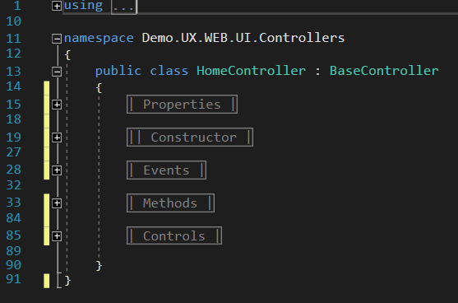

.NET Coding Standards

These coding standards can be applied to C# and VB.NET.
  - Design Guidelines for Developing Class Libraries
The Design Guidelines for Developing Class Libraries document is a fairly thorough discussion of how to write managed code. The information in this section highlights some important standards and lists the framework samples guidelines. Therefore, you had better read the two documents side by side.
  - Files and Structure
☒ Do not have more than one public type in a source file, unless they differ only in the number of generic parameters or one is nested in the other. Multiple internal types in one file are allowed.

☑ Do name the source file with the name of the public type it contains. For example, MainForm class should be in MainForm.cs file and List<T> class should be in List.cs file.
  - Assembly Properties
The assembly should contain the appropriate property values describing its name, copyright, and so on.

Standard | Example
Set Copyright to Copyright © Microsoft Corporation 2010 | [assembly: AssemblyCopyright("Copyright © Microsoft Corporation 2010")]
Set AssemblyCompany to Microsoft Corporation | [assembly: AssemblyCompany("Microsoft Corporation")]
Set both AssemblyTitle and AssemblyProduct to the current sample name | [assembly: AssemblyTitle("CSNamedPipeClient")]  [assembly: AssemblyProduct("CSNamedPipeClient")]
  - Naming Convensions
    - General Naming Conventions
☑ Do use meaning names for various types, functions, variables, constructs and types.

☒ You should not use of shortenings or contractions as parts of identifier names. For example, use “GetWindow” rather than “GetWin”. For functions of common types, thread procs, window procedures, dialog procedures use the common suffixes for these “ThreadProc”, “DialogProc”, “WndProc”.

☒ Do not use underscores, hyphens, or any other non-alphanumeric characters.

    - Capitalization Naming Rules for Identifiers
You ought to follow these three naming conventions below regarding its usage:
- Pascal Case:
Pascal Case is the practice of writing compound words or phrases such that the first letter of each concatenated word is capitalize. Example: BackColor.
- Camel Case:
The first letter of an identifier is lowercase and the first letter of each subsequent concatenated word is capitalized. For example:. Example: borderColor.

- Upper Case:
All letters in the identifier are capitalized. Use this convention only for identifiers that consist of two or fewer letters. For example: BES, DAL, BLL, UI, DM.
The following table describes the capitalization and naming rules for different types of identifiers.

Identifier | Case | Example
Class | Pascal | public class OrderItem
Enum | Pascal | public enum ConsoleModifiers
Enum Values | Pascal | { Alt, Control }
Event | Pascal | public event WindowClosed
Exception | Pascal | IndexOutOfRangeException
Read-only Static Field | Pascal | RedValue
Interface | ‘I’ Prefix + Pascal | IDisposable, Idictionary, when using _IServiceBase
Method | Pascal | public void GetOrder()
Namespace | Pascal | namespace Microsoft.Sample.Windows7
Parameter | Pascal | private int OrderNumber
Property | Pascal | public string CustomerName
Protected | Pascal | protected void Run()
Private | Camel | private int orderID
Delegate | Pascal | public delegate WindowClosedEventHandler
Constant | UpperCase | public const string MessageText = "A";
Generic Type | ‘T’ Prefix + Pascal | T, TItem, TPolicy
  - UI Control Naming Conventions
Below are the prefixes that should be used to name the controls used by the application.
Identifier | Control | Example
lbl | Label | lblName
btn | Button | btnSave
txt | TextBox | txtName
mnu | MainMenu | mnuForm
chk | CheckBox | chkIsRequired
rdo | RadioButton | rdoIsOK
gdv | GridView | gdvItens
lst | ListBox | lstItens
lstv | ListView | lstvItens
ddl | DropDownList | ddlStates
cbo | ComboBox | cboCountries
pgb | ProgressBar | pgbStatus
frm | Form | frmStatus
ofd | OpenFileDialog | ofdBrowse
fsw | FileSystemWatcher | FswItensToSave
ddl | DropDownList | ddlProdutos
  - Hungarian Notation
☒ Do not use Hungarian notation (i.e., do not encode the type of a variable in its name) in .NET.
  - Constants
☑ Do use constant fields for constants that will never change. The compiler burns the values of const fields directly into calling code. Therefore const values can never be changed without the risk of breaking compatibility.

public class Int32
{
public const int MaxValue = 0x7fffffff;
public const int MinValue = unchecked((int)0x80000000);
}

☑ Do use public static (shared) readonly fields for predefined object instances. If there are predefined instances of the type, declare them as public readonly static fields of the type itself. For example,

public class ShellFolder
{
public static readonly ShellFolder ProgramData = new ShellFolder("ProgramData");
public static readonly ShellFolder ProgramFiles = new ShellFolder("ProgramData");
...
}
  - Strings
☒ Do not use the ‘+’ operator (or ‘&’ in VB.NET) to concatenate many strings. Instead, you should use StringBuilder for concatenation. However, do use the ‘+’ operator (or ‘&’ in VB.NET) to concatenate small numbers of strings.

☑ Good:
StringBuilder sb = new StringBuilder();
for (int i = 0; i < 10; i++)
{
sb.Append(i.ToString());
}

☒ Bad:
string str = string.Empty;
for (int i = 0; i < 10; i++)
{
str += i.ToString();
}

☑ Do use overloads that explicitly specify the string comparison rules for string operations. Typically, this involves calling a method overload that has a parameter of type StringComparison.

☑ Do use StringComparison.Ordinal or StringComparison.OrdinalIgnoreCase for comparisons as your safe default for culture-agnostic string matching, and for better performance.

☑ Do use string operations that are based on StringComparison.CurrentCulture when you display output to the user.

☑ Do use the non-linguistic StringComparison.Ordinal or StringComparison.OrdinalIgnoreCase values instead of string operations based on CultureInfo.InvariantCulture when the comparison is linguistically irrelevant (symbolic, for example). Do not use string operations based on StringComparison.InvariantCulture in most cases. One of the few exceptions is when you are persisting linguistically meaningful but culturally agnostic data.

☑ Do use an overload of the String.Equals method to test whether two strings are equal. For example, to test if two strings are equal ignoring the case,

if (str1.Equals(str2, StringComparison.OrdinalIgnoreCase))

If (str1.Equals(str2, StringComparison.OrdinalIgnoreCase)) Then

☒ Do not use an overload of the String.Compare or CompareTo method and test for a return value of zero to determine whether two strings are equal. They are used to sort strings, not to check for equality.

☑ Do use the String.ToUpperInvariant method instead of the String.ToLowerInvariant method when you normalize strings for comparison.
  - Arrays and Collections
☑ You should use arrays in low-level functions to minimize memory consumption and maximize performance. In public interfaces, do prefer collections over arrays.

Collections provide more control over contents, can evolve over time, and are more usable. In addition, using arrays for read-only scenarios is discouraged as the cost of cloning the array is prohibitive.

However, if you are targeting more skilled developers and usability is less of a concern, it might be better to use arrays for read-write scenarios. Arrays have a smaller memory footprint, which helps reduce the working set, and access to elements in an array is faster as it is optimized by the runtime.

☒ Do not use read-only array fields. The field itself is read-only and can’t be changed, but elements in the array can be changed. This example demonstrates the pitfalls of using read-only array fields:

☒ Bad:
public static readonly char[] InvalidPathChars = { '\"', '<', '>', '|'};

This allows callers to change the values in the array as follows:

InvalidPathChars[0] = 'A';

Instead, you can use either a read-only collection (only if the items are immutable) or clone the array before returning it. However, the cost of cloning the array may be prohibitive.

public static ReadOnlyCollection<char> GetInvalidPathChars()
{
return Array.AsReadOnly(badChars);
}

public static char[] GetInvalidPathChars()
{
return (char[])badChars.Clone();
}

☑ You should use jagged arrays instead of multidimensional arrays. A jagged array is an array with elements that are also arrays. The arrays that make up the elements can be of different sizes, leading to less wasted space for some sets of data (e.g., sparse matrix), as compared to multidimensional arrays. Furthermore, the CLR optimizes index operations on jagged arrays, so they might exhibit better runtime performance in some scenarios.

// Jagged arrays
int[][] jaggedArray =
{
new int[] {1, 2, 3, 4},
new int[] {5, 6, 7},
new int[] {8},
new int[] {9}
};

// Multidimensional arrays
int [,] multiDimArray =
{
{1, 2, 3, 4},
{5, 6, 7, 0},
{8, 0, 0, 0},
{9, 0, 0, 0}
};

☑ Do use Collection<T> or a subclass of Collection<T> for properties or return values representing read/write collections, and use ReadOnlyCollection<T> or a subclass of ReadOnlyCollection<T> for properties or return values representing read-only collections.

☑ You should reconsider the use of ArrayList because any objects added into the ArrayList are added as System.Object and when retrieving values back from the arraylist, these objects are to be unboxed to return the actual value type. So it is recommended to use the custom typed collections instead of ArrayList. For example, .NET provides a strongly typed collection class for String in System.Collection.Specialized, namely StringCollection.

☑ You should reconsider the use of Hashtable. Instead, try other dictionary such as StringDictionary, NameValueCollection, HybridCollection. Hashtable can be used if less number of values is stored.

☑ When you are creating a collection type, you should implement IEnumerable so that the collection can be used with LINQ to Objects.

☒ Do not implement both IEnumerator<T> and IEnumerable<T> on the same type. The same applies to the nongeneric interfaces IEnumerator and IEnumerable. In other words, a type should be either a collection or an enumerator, but not both.

☒ Do not return a null reference for Array or Collection. Null can be difficult to understand in this context. For example, a user might assume that the following code will work. Return an empty array or collection instead of a null reference.

int[] arr = SomeOtherFunc();
foreach (int v in arr)
{
...
}
  - Structures
☑ Do ensure that a state where all instance data is set to zero, false, or null (as appropriate) is valid. This prevents accidental creation of invalid instances when an array of the structs is created.

☑ Do implement IEquatable<T> on value types. The Object.Equals method on value types causes boxing and its default implementation is not very efficient, as it uses reflection. IEquatable<T>.Equals can have much better performance and can be implemented such that it will not cause boxing.
  - Structures vs. Classes
☒ Do not define a struct unless the type has all of the following characteristics:

- It logically represents a single value, similar to primitive types (int, double, etc.).
- It has an instance size fewer than 16 bytes.
- It is immutable.
- It will not have to be boxed frequently.

In all other cases, you should define your types as classes instead of structs.
  - Classes
☑ Do use inheritance to express “is a” relationships such as “cat is an animal”.

☑ Do use interfaces such as IDisposable to express “can do” relationships such as using “objects of this class can be disposed”.

  - Fields
☒ Do not provide instance fields that are public or protected. Public and protected fields do not version well and are not protected by code access security demands. Instead of using publicly visible fields, use private fields and expose them through properties.

☑ Do use public static read-only fields for predefined object instances.

☑ Do use constant fields for constants that will never change.

☒ Do not assign instances of mutable types to read-only fields.
  - Properties
☑ Do create read-only properties if the caller should not be able to change the value of the property.

☒ Do not provide set-only properties. If the property getter cannot be provided, use a method to implement the functionality instead. The method name should begin with Set followed by what would have been the property name.

☑ Do provide sensible default values for all properties, ensuring that the defaults do not result in a security hole or an extremely inefficient design.

☒ You should not throw exceptions from property getters. Property getters should be simple operations without any preconditions. If a getter might throw an exception, consider redesigning the property to be a method. This recommendation does not apply to indexers. Indexers can throw exceptions because of invalid arguments. It is valid and acceptable to throw exceptions from a property setter.
  - Constructors
☑ Do minimal work in the constructor. Constructors should not do much work other than to capture the constructor parameters and set main properties. The cost of any other processing should be delayed until required.

☑ Do throw exceptions from instance constructors if appropriate.

☑ Do explicitly declare the public default constructor in classes, if such a constructor is required. Even though some compilers automatically add a default constructor to your class, adding it explicitly makes code maintenance easier. It also ensures the default constructor remains defined even if the compiler stops emitting it because you add a constructor that takes parameters.

☒ Do not call virtual members on an object inside its constructors. Calling a virtual member causes the most-derived override to be called regardless of whether the constructor for the type that defines the most-derived override has been called.
  - Methods
☑ Do place all out parameters after all of the pass-by-value and ref parameters (excluding parameter arrays), even if this results in an inconsistency in parameter ordering between overloads.

☑ Do validate arguments passed to public, protected, or explicitly implemented members. Throw System.ArgumentException, or one of its subclasses, if the validation fails: If a null argument is passed and the member does not support null arguments, throw ArgumentNullException. If the value of an argument is outside the allowable range of values as defined by the invoked method, throw ArgumentOutOfRangeException.
  - Events
☑ Do be prepared for arbitrary code executing in the event-handling method. Consider placing the code where the event is raised in a try-catch block to prevent program termination due to unhandled exceptions thrown from the event handlers.

☒ Do not use events in performance sensitive APIs. While events are easier for many developers to understand and use, they are less desirable than Virtual Members from a performance and memory consumption perspective.
  - Member Overloading
☑ Do use member overloading rather than defining members with default arguments. Default arguments are not CLS-compliant and cannot be used from some languages. There is also a versioning issue in members with default arguments. Imagine version 1 of a method that sets an optional parameter to 123. When compiling code that calls this method without specifying the optional parameter, the compiler will embed the default value (123) into the code at the call site. Now, if version 2 of the method changes the optional parameter to 863, then, if the calling code is not recompiled, it will call version 2 of the method passing in 123 (version 1’s default, not version 2’s default).

☑ Good:
Public Overloads Sub Rotate(ByVal data As Matrix)
Rotate(data, 180)
End Sub

Public Overloads Sub Rotate(ByVal data As Matrix, ByVal degrees As Integer)
' Do rotation here
End Sub

☒ Bad:
Public Sub Rotate(ByVal data As Matrix, Optional ByVal degrees As Integer = 180)
' Do rotation here
End Sub

☒ Do not arbitrarily vary parameter names in overloads. If a parameter in one overload represents the same input as a parameter in another overload, the parameters should have the same name. Parameters with the same name should appear in the same position in all overloads.

☑ Do make only the longest overload virtual (if extensibility is required). Shorter overloads should simply call through to a longer overload.
  - Interface Members
☒ You should not implement interface members explicitly without having a strong reason to do so. Explicitly implemented members can be confusing to developers because they don’t appear in the list of public members and they can also cause unnecessary boxing of value types.

☑ You should implement interface members explicitly, if the members are intended to be called only through the interface.
  - Virtual Members
Virtual members perform better than callbacks and events, but do not perform better than non-virtual methods.

☒ Do not make members virtual unless you have a good reason to do so and you are aware of all the costs related to designing, testing, and maintaining virtual members.

☑ You should prefer protected accessibility over public accessibility for virtual members. Public members should provide extensibility (if required) by calling into a protected virtual member.
  - Static Classes
☑ Do use static classes sparingly. Static classes should be used only as supporting classes for the object-oriented core of the framework.

  - Abstract Classes
☒ Do not define public or protected-internal constructors in abstract types.

☑ Do define a protected or an internal constructor on abstract classes.

A protected constructor is more common and simply allows the base class to do its own initialization when subtypes are created.

public abstract class Claim
{
protected Claim()
{
...
}
}

An internal constructor can be used to limit concrete implementations of the abstract class to the assembly defining the class.

public abstract class Claim
{
internal Claim()
{
...
}
}
  - Namespaces
☑ Do use the following definitions when setting up the namespaces and project’s name within a solution in the Visual Studio.
Example: Corp.DemoProject (Solution)
Corp.DemoProject.BES
Corp.DemoProject.BLL
Corp.DemoProject.DAL
Corp.DemoProject.WIN.UI
  - Fully Qualified Name
Don’t use Fully Qualified Name to add a namespace reference, instead use the “using” at the top of the class.
Only use Fully Qualified Name whenever there is ambiguity of class names between assemblies.
Example:
using System.IO;
Reference: http://msdn.microsoft.com/en-us/library/dfb3cx8s(v=VS.100).aspx
  - TODO
When writing comments, try use keywords that are recognized by “Task List:

Example:
// TODO: Place Database Code Here
// UNDONE: Removed P\Invoke Call due to errors
  - Boxing
Avoid boxing and unboxing of value types.
Example:
int count = 1;
object refCount = count; // Implicitly boxed.
int newCount = (int)refCount; // Explicitly unboxed.
  - Errors and Exceptions
    - Exception Throwing
☑ Do report execution failures by throwing exceptions. Exceptions are the primary means of reporting errors in frameworks. If a member cannot successfully do what it is designed to do, it should be considered an execution failure and an exception should be thrown. Do not return error codes.

☑ Do throw the most specific (the most derived) exception that makes sense. For example, throw ArgumentNullException and not its base type ArgumentException if a null argument is passed. Throwing System.Exception as well as catching System.Exception are nearly always the wrong thing to do.

☒ Do not use exceptions for the normal flow of control, if possible. Except for system failures and operations with potential race conditions, you should write code that does not throw exceptions. For example, you can check preconditions before calling a method that may fail and throw exceptions. For example,

// C# sample:
if (collection != null && !collection.IsReadOnly)
{
collection.Add(additionalNumber);
}

☒ Do not throw exceptions from exception filter blocks. When an exception filter raises an exception, the exception is caught by the CLR, and the filter returns false. This behavior is indistinguishable from the filter executing and returning false explicitly and is therefore very difficult to debug.

' VB.NET sample
' This is bad design. The exception filter (When clause)
' may throw an exception when the InnerException property
' returns null
Try
...
Catch e As ArgumentException _
When e.InnerException.Message.StartsWith("File")
...
End Try

☒ Do not explicitly throw exceptions from finally blocks. Implicitly thrown exceptions resulting from calling methods that throw are acceptable.
    - Exception Handling
☒ You should not swallow errors by catching nonspecific exceptions, such as System.Exception, System.SystemException, and so on in .NET code. Do catch only specific errors that the code knows how to handle. You should catch a more specific exception, or re-throw the general exception as the last statement in the catch block. There are cases when swallowing errors in applications is acceptable, but such cases are rare.

☑ Good:
// C# sample:
try
{
...
}
catch(System.NullReferenceException exc)
{
...
}
catch(System.ArgumentOutOfRangeException exc)
{
...
}
catch(System.InvalidCastException exc)
{
...
}

☒ Bad:
// C# sample:
try
{
...
}
catch (Exception ex)
{
...
}

☑ Do prefer using an empty throw when catching and re-throwing an exception. This is the best way to preserve the exception call stack.

☑ Good:
// C# sample:
try
{
... // Do some reading with the file
}
catch
{
file.Position = position; // Unwind on failure
throw; // Rethrow
}

☒ Bad:
// C# sample:
try
{
... // Do some reading with the file
}
catch (Exception ex)
{
file.Position = position; // Unwind on failure
throw ex; // Rethrow
}

  - Resource Cleanup
☒ Do not force garbage collections with GC.Collect.

  - Try-finally Block
☑ Do use try-finally blocks for cleanup code and try-catch blocks for error recovery code. Do not use catch blocks for cleanup code. Usually, the cleanup logic rolls back resource (particularly, native resource) allocations. For example,

// C# sample:
FileStream stream = null;
try
{
stream = new FileStream(...);
...
}
finally
{
if (stream != null)
{
stream.Close();
}
}

C# and VB.NET provide the using statement that can be used instead of plain try-finally to clean up objects implementing the IDisposable interface.

// C# sample:
using (FileStream stream = new FileStream(...))
{
...
}

Many language constructs emit try-finally blocks automatically for you. Examples are C#/VB’s using statement, C#’s lock statement, VB’s SyncLock statement, C#’s foreach statement, and VB’s For Each statement.
  - IDisposable Interface
Instantiate the objects that implements the IDisposable interface using the keyword “using” to make sure that the Dispose method will be trigger automatically as soon as the code execution goes to the next line.
Example:
using(var oConnection = new SqlConnection(connectionString))
{
// YOUR CODE GOES HERE
}
  - Basic Dispose Pattern
The basic implementation of the pattern involves implementing the System.IDisposable interface and declaring the Dispose(bool) method that implements all resource cleanup logic to be shared between the Dispose method and the optional finalizer. Please note that this section does not discuss providing a finalizer. Finalizable types are extensions to this basic pattern and are discussed in the next section. The following example shows a simple implementation of the basic pattern:

// C# sample:
public class DisposableResourceHolder : IDisposable
{
private bool disposed = false;
private SafeHandle resource; // Handle to a resource

public DisposableResourceHolder()
{
this.resource = ... // Allocates the native resource
}

public void DoSomething()
{
if (disposed)
{
throw new ObjectDisposedException(...);
}

// Now call some native methods using the resource
...
}

public void Dispose()
{
Dispose(true);
GC.SuppressFinalize(this);
}

protected virtual void Dispose(bool disposing)
{
// Protect from being called multiple times.
if (disposed)
{
return;
}

if (disposing)
{
// Clean up all managed resources.
if (resource != null)
{
resource.Dispose();
}
}

disposed = true;
}
}

☑ Do implement the Basic Dispose Pattern on types containing instances of disposable types.

☑ Do extend the Basic Dispose Pattern to provide a finalizer on types holding resources that need to be freed explicitly and that do not have finalizers. For example, the pattern should be implemented on types storing unmanaged memory buffers.

☑ You should implement the Basic Dispose Pattern on classes that themselves don’t hold unmanaged resources or disposable objects but are likely to have subtypes that do. A great example of this is the System.IO.Stream class. Although it is an abstract base class that doesn’t hold any resources, most of its subclasses do and because of this, it implements this pattern.

☑ Do declare a protected virtual void Dispose(bool disposing) method to centralize all logic related to releasing unmanaged resources. All resource cleanup should occur in this method. The method is called from both the finalizer and the IDisposable.Dispose method. The parameter will be false if being invoked from inside a finalizer. It should be used to ensure any code running during finalization is not accessing other finalizable objects. Details of implementing finalizers are described in the next section.

// C# sample:
protected virtual void Dispose(bool disposing)
{
// Protect from being called multiple times.
if (disposed)
{
return;
}

if (disposing)
{
// Clean up all managed resources.
if (resource != null)
{
resource.Dispose();
}
}

disposed = true;
}

☑ Do implement the IDisposable interface by simply calling Dispose(true) followed by GC.SuppressFinalize(this). The call to SuppressFinalize should only occur if Dispose(true) executes successfully.

// C# sample:
public void Dispose()
{
Dispose(true);
GC.SuppressFinalize(this);
}

☒ Do not make the parameterless Dispose method virtual. The Dispose(bool) method is the one that should be overridden by subclasses.

☒ You should not throw an exception from within Dispose(bool) except under critical situations where the containing process has been corrupted (leaks, inconsistent shared state, etc.). Users expect that a call to Dispose would not raise an exception. For example, consider the manual try-finally in this C# snippet:

TextReader tr = new StreamReader(File.OpenRead("foo.txt"));
try
{
// Do some stuff
}
finally
{
tr.Dispose();
// More stuff
}

If Dispose could raise an exception, further finally block cleanup logic will not execute. To work around this, the user would need to wrap every call to Dispose (within their finally block!) in a try block, which leads to very complex cleanup handlers. If executing a Dispose(bool disposing) method, never throw an exception if disposing is false. Doing so will terminate the process if executing inside a finalizer context.

☑ Do throw an ObjectDisposedException from any member that cannot be used after the object has been disposed.

// C# sample:
public class DisposableResourceHolder : IDisposable
{
private bool disposed = false;
private SafeHandle resource; // Handle to a resource

public void DoSomething()
{
if (disposed)
{
throw new ObjectDisposedException(...);
}

// Now call some native methods using the resource
...
}

protected virtual void Dispose(bool disposing)
{
if (disposed)
{
return;
}

// Cleanup
...

disposed = true;
}
}

  - Finalizable Types | Destructor
Finalizable types are types that extend the Basic Dispose Pattern by overriding the finalizer and providing finalization code path in the Dispose(bool) method. The following code shows an example of a finalizable type:

// C# sample:
public class ComplexResourceHolder : IDisposable
{
bool disposed = false;
private IntPtr buffer; // Unmanaged memory buffer
private SafeHandle resource; // Disposable handle to a resource

public ComplexResourceHolder()
{
this.buffer = ... // Allocates memory
this.resource = ... // Allocates the resource
}

public void DoSomething()
{
if (disposed)
{
throw new ObjectDisposedException(...);
}

// Now call some native methods using the resource
...
}

~ComplexResourceHolder()
{
Dispose(false);
}

public void Dispose()
{
Dispose(true);
GC.SuppressFinalize(this);
}

protected virtual void Dispose(bool disposing)
{
// Protect from being called multiple times.
if (disposed)
{
return;
}

if (disposing)
{
// Clean up all managed resources.
if (resource != null)
{
resource.Dispose();
}
}

// Clean up all native resources.
ReleaseBuffer(buffer);

disposed = true;
}
}

☑ Do make a type finalizable, if the type is responsible for releasing an unmanaged resource that does not have its own finalizer. When implementing the finalizer, simply call Dispose(false) and place all resource cleanup logic inside the Dispose(bool disposing) method.

// C# sample:
public class ComplexResourceHolder : IDisposable
{
...
~ComplexResourceHolder()
{
Dispose(false);
}

protected virtual void Dispose(bool disposing)
{
...
}
}

☑ Do be very careful to make type finalizable. Carefully consider any case in which you think a finalizer is needed. There is a real cost associated with instances with finalizers, from both a performance and code complexity standpoint.

☑ Do implement the Basic Dispose Pattern on every finalizable type. See the previous section for details on the basic pattern. This gives users of the type a means to explicitly perform deterministic cleanup of those same resources for which the finalizer is responsible.

☑ You should create and use a critical finalizable object (a type with a type hierarchy that contains CriticalFinalizerObject) for situations in which a finalizer absolutely must execute even in the face of forced application domain unloads and thread aborts.

☑ Do prefer resource wrappers based on SafeHandle or SafeHandleZeroOrMinusOneIsInvalid (for Win32 resource handle whose value of either 0 or -1 indicates an invalid handle) to writing finalizer by yourself to encapsulate unmanaged resources where possible, in which case a finalizer becomes unnecessary because the wrapper is responsible for its own resource cleanup. Safe handles implement the IDisposable interface, and inherit from CriticalFinalizerObject so the finalizer logic will absolutely execute even in the face of forced application domain unloads and thread aborts.

/// <summary>
/// Represents a wrapper class for a pipe handle.
/// </summary>
[SecurityCritical(SecurityCriticalScope.Everything),
HostProtection(SecurityAction.LinkDemand, MayLeakOnAbort = true),
SecurityPermission(SecurityAction.LinkDemand, UnmanagedCode = true)]
internal sealed class SafePipeHandle : SafeHandleZeroOrMinusOneIsInvalid
{
private SafePipeHandle()
: base(true)
{
}

public SafePipeHandle(IntPtr preexistingHandle, bool ownsHandle)
: base(ownsHandle)
{
base.SetHandle(preexistingHandle);
}

[ReliabilityContract(Consistency.WillNotCorruptState, Cer.Success),
DllImport("kernel32.dll", CharSet = CharSet.Auto, SetLastError = true)]
[return: MarshalAs(UnmanagedType.Bool)]
private static extern bool CloseHandle(IntPtr handle);

protected override bool ReleaseHandle()
{
return CloseHandle(base.handle);
}
}

/// <summary>
/// Represents a wrapper class for a local memory pointer.
/// </summary>
[SuppressUnmanagedCodeSecurity,
HostProtection(SecurityAction.LinkDemand, MayLeakOnAbort = true)]
internal sealed class SafeLocalMemHandle : SafeHandleZeroOrMinusOneIsInvalid
{
public SafeLocalMemHandle()
: base(true)
{
}

public SafeLocalMemHandle(IntPtr preexistingHandle, bool ownsHandle)
: base(ownsHandle)
{
base.SetHandle(preexistingHandle);
}

[ReliabilityContract(Consistency.WillNotCorruptState, Cer.Success),
DllImport("kernel32.dll", CharSet = CharSet.Auto, SetLastError = true)]
private static extern IntPtr LocalFree(IntPtr hMem);

protected override bool ReleaseHandle()
{
return (LocalFree(base.handle) == IntPtr.Zero);
}
}

☒ Do not access any finalizable objects in the finalizer code path, as there is significant risk that they will have already been finalized. For example, a finalizable object A that has a reference to another finalizable object B cannot reliably use B in A’s finalizer, or vice versa. Finalizers are called in a random order (short of a weak ordering guarantee for critical finalization).

It is OK to touch unboxed value type fields.

Also, be aware that objects stored in static variables will get collected at certain points during an application domain unload or while exiting the process. Accessing a static variable that refers to a finalizable object (or calling a static method that might use values stored in static variables) might not be safe if Environment.HasShutdownStarted returns true.
☒ Do not let exceptions escape from the finalizer logic, except for system-critical failures. If an exception is thrown from a finalizer, the CLR may shut down the entire process preventing other finalizers from executing and resources from being released in a controlled manner.
  - Overriding Dispose
If you're inheriting from a base class that implements IDisposable, you must implement IDisposable also. Always call your base class's Dispose(bool) so it cleans up.

public class DisposableBase : IDisposable
{
~DisposableBase()
{
Dispose(false);
}

public void Dispose()
{
Dispose(true);
GC.SuppressFinalize(this);
}

protected virtual void Dispose(bool disposing)
{
// ...
}
}

public class DisposableSubclass : DisposableBase
{
protected override void Dispose(bool disposing)
{
try
{
if (disposing)
{
// Clean up managed resources.
}

// Clean up native resources.
}
finally
{
base.Dispose(disposing);
}
}
}
  - Interop
    - P/Invoke
☑ Do consult P/Invoke Interop Assistant and http://pinvoke.net to write P/Invoke signatures.

☑ You can use IntPtr for manual marshaling. By declaring parameters and fields as IntPtr, you can boost performance, albeit at the expense of ease of use, type safety, and maintainability. Sometimes it is faster to perform manual marshaling by using methods available on the Marshal class rather than to rely on default interop marshaling. For example, if large arrays of strings need to be passed across an interop boundary, but the managed code needs only a few of those elements, you can declare the array as IntPtr and manually access only those few elements that are required.

☒ Do not aggressively pin short-lived objects. Pinning short-lived objects unnecessarily extends the life of a memory buffer beyond the duration of the P/Invoke call. Pinning prevents the garbage collector from relocating the bytes of the object in the managed heap, or relocating the address of a managed delegate. However, it is acceptable to pin long-lived objects, which are ideally created during application initialization, because they are not moved relative to short-lived objects. It is costly to pin short-lived objects for a long period of time, because compacting occurs most in Generation 0 and the garbage collector cannot relocate pinned objects. This results in inefficient memory management that can adversely affect performance. For more information about copying and pinning, see http://msdn.microsoft.com/en-us/library/23acw07k.aspx.

☑ Do set CharSet = CharSet.Auto and SetLastError = true in the P/Invoke signature. For example,

// C# sample:
[DllImport("kernel32.dll", CharSet = CharSet.Auto, SetLastError = true)]
public static extern SafeFileMappingHandle OpenFileMapping(
FileMapAccess dwDesiredAccess, bool bInheritHandle, string lpName);

' VB.NET sample:
<DllImport("kernel32.dll", CharSet:=CharSet.Auto, SetLastError:=True)> _
Public Shared Function OpenFileMapping( _
ByVal dwDesiredAccess As FileMapAccess, _
ByVal bInheritHandle As Boolean, _
ByVal lpName As String) _
As SafeFileMappingHandle
End Function

☑ You should wrap unmanaged resources in SafeHandle classes. The SafeHandle class is discussed in the Finalizable Types section. For example, the handle of file mapping is wrapped as follows.

/// <summary>
/// Represents a wrapper class for a file mapping handle.
/// </summary>
[SuppressUnmanagedCodeSecurity,
HostProtection(SecurityAction.LinkDemand, MayLeakOnAbort = true)]
internal sealed class SafeFileMappingHandle : SafeHandleZeroOrMinusOneIsInvalid
{
[SecurityPermission(SecurityAction.LinkDemand, UnmanagedCode = true)]
private SafeFileMappingHandle()
: base(true)
{
}

[SecurityPermission(SecurityAction.LinkDemand, UnmanagedCode = true)]
public SafeFileMappingHandle(IntPtr handle, bool ownsHandle)
: base(ownsHandle)
{
base.SetHandle(handle);
}

[ReliabilityContract(Consistency.WillNotCorruptState, Cer.Success),
DllImport("kernel32.dll", CharSet = CharSet.Auto, SetLastError = true)]
[return: MarshalAs(UnmanagedType.Bool)]
private static extern bool CloseHandle(IntPtr handle);

protected override bool ReleaseHandle()
{
return CloseHandle(base.handle);
}
}

''' <summary>
''' Represents a wrapper class for a file mapping handle.
''' </summary>
''' <remarks></remarks>
<SuppressUnmanagedCodeSecurity(), _
HostProtection(SecurityAction.LinkDemand, MayLeakOnAbort:=True)> _
Friend NotInheritable Class SafeFileMappingHandle
Inherits SafeHandleZeroOrMinusOneIsInvalid

<SecurityPermission(SecurityAction.LinkDemand, UnmanagedCode:=True)> _
Private Sub New()
MyBase.New(True)
End Sub

<SecurityPermission(SecurityAction.LinkDemand, UnmanagedCode:=True)> _
Public Sub New(ByVal handle As IntPtr, ByVal ownsHandle As Boolean)
MyBase.New(ownsHandle)
MyBase.SetHandle(handle)
End Sub

<ReliabilityContract(Consistency.WillNotCorruptState, Cer.Success), _
DllImport("kernel32.dll", CharSet:=CharSet.Auto, SetLastError:=True)> _
Private Shared Function CloseHandle(ByVal handle As IntPtr) _
As <MarshalAs(UnmanagedType.Bool)> Boolean
End Function

Protected Overrides Function ReleaseHandle() As Boolean
Return SafeFileMappingHandle.CloseHandle(MyBase.handle)
End Function

End Class

☑ You should throw Win32Exception on the failure of P/Invoked functions that set the Win32 last error. If the function uses some unmanaged resources, free the resource in the finally block.

// C# sample:
SafeFileMappingHandle hMapFile = null;
try
{
// Try to open the named file mapping.
hMapFile = NativeMethod.OpenFileMapping(
FileMapAccess.FILE_MAP_READ, // Read access
false, // Do not inherit the name
FULL_MAP_NAME // File mapping name
);
if (hMapFile.IsInvalid)
{
throw new Win32Exception();
}

...
}
finally
{
if (hMapFile != null)
{
// Close the file mapping object.
hMapFile.Close();
hMapFile = null;
}
}

  - COM Interop
☒ Do not force garbage collections with GC.Collect to release COM objects in performance sensitive APIs. A common approach for releasing COM objects is to set the RCW reference to null, and call System.GC.Collect followed by System.GC.WaitForPendingFinalizers. This is not recommended for performance reasons, because in many situations it can trigger the garbage collector to run too often. Code written by using this approach significantly compromises the performance and scalability of server applications. You should let the garbage collector determine the appropriate time to perform a collection.

☑ You should use Marshal.FinalReleaseComObject or Marshal.ReleaseComObject to manage the lifetime of an RCW manually. It has much better performance than forcing garbage collections with GC.Collect.

☒ Do not make cross-apartment calls. When you call a COM object from a managed application, make sure that the managed code's apartment matches the COM object's apartment type. By using matching apartments, you avoid the thread switch associated with cross-apartment calls.
  - Abbreviation
☒ Do not use Abbreviations. Exceptions: abbreviations commonly used as names, such as Id, Xml, Ftp, Uri.
- ☑ Good
- UserGroup userGroup;
- Assignment employeeAssignment;

- ☒ Bad
- UserGroup usrGrp;
- Assignment empAssignment;

- // Exceptions
- CustomerId customerId;
- XmlDocument xmlDocument;
- FtpHelper ftpHelper;
- UriPart uriPart;

.NET Coding Standards
The Framework is a centralized and unified library that has a bunch of helpful methods that makes the development efforts as easy as a walk in the park. It avoids redundant code among, improve the software quality and ensure that the code has been tested and optimized prior to be released to be used by the team.
- Improve productivity in the software development life cycle (SDLC);
- Source code reutilization;
- Coding Standards;
- Security and Reliability;
- Stability;
- Easy and Unified maintenance;
With regards to development, you must use the components available in the Framework, and make sure that it complies to the best patterns and practices hereby described.
Below we have a list of the available components and its namespaces:
- Framework.Cache
- Framework.Core
- Framework.Cryptography
- Framework.Data
- Framework.Data.SQL
- Framework.Dynamic
- Framework.Entity
- Framework.FTP
- Framework.Impersonation
- Framework.IO
- Framework.Logging
- Framework.MQ.IBM
- Framework.Office
- Framework.SFTP
- Framework.Web.Forms
- Framework.Web.MVC
- Framework.WebAPI.Cache
- Framework.WebAPI.CrossClient
- Framework.Windows.Forms

Framework Architecture
The start a new project from the scratch, all projects must follow the given definitions described below:

BES - Business Entity Structure (MODEL !!!)
In this project, we have the domain model classes that represents data from a table, view or whatever. The Framework has an automatic property mapping mechanism that fills the class properties with the corresponding value from a data source column without using REFLECTION. The class mapping can be changed dynamically by using a web.config or app.config file, or hard-coded.

BLL - Business Logic Layer
Business logic classes must implement the application logic that is concerned with the input validation, business validation, data retrieval, processing, transformation, and management of application data; application of business rules and policies; and ensuring data consistency and validity. To maximize reuse opportunities, business logic components should not contain any behavior or application logic that is specific to a use case or user story.

DAL - Data Access Layer
Data Access Layer holds a common set of methods that are required to perform any operation in an underlying database. These class will have methods CRUD operations and will get the parameters from Business logic layer. This layer uses the SOLID pattern and Dependency injection.
It also provides Multiple Active Result sets (MARS), T-SQL Statement Visualization and Logging, Automatic Code Generation and avoids reflection utilization when mapping the properties to improve the application performance.
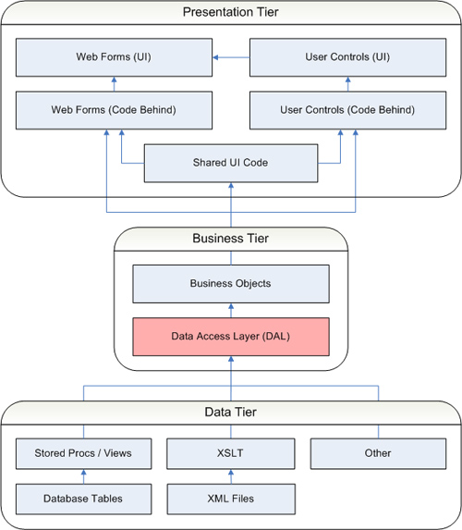
Extensions Methods
There are a lot of useful extensions methods in the “Framework.Core” that will be handy for you when developing an application regardless its project type.

API Integration process

Punchout Setup Request
In order to get any information provided by the company WebApi Layer or ESB, every application must perform an inicial hankshake process called “Punchout setup request”. This process consists of sending the procurement application information (ClientId, SharedSecret) that will be validated and once the information is correct, a response will be send back with the information that will grant access to the WebApi.
/ CompanyTokenId
/ ApiEndpoint
To move forward, the procurement application must start the authentication/authorization process. Using the ApiEndpoing address that came from the Punchout Setup Request, the application must invoke the “authentication” method passing the CompanyTokenId/Username/Password, that will return a custom token in case of success. The generated token will be used throughout the following requests until it is valid regarding its expiration date.
The authenticate method must be invoked over and over again since the token is invalid/expired;

Custom Token-Based Authentication and Authorization using WebAPI
Since the Web API adoption is increasing at a rapid pace, there is a serious need for implementing security for all types of clients trying to access data from Web API services. One of the most preferred mechanism is to authenticate client over HTTP using a signed token. Simply put, a token is a piece of data which is created by a server, and which contains enough data to identify a particular user. The process starts by allowing users to enter their username and password which accessing a service. Once the user provides the username/password, a token is issued which allows users to fetch a specific resource - without using their username and password every time. This token is sent to the server with each request made by the client and contains all necessary information to validate a user’s request. The following diagram explains how Token-Based authentication is used in communication between clients and server.
Advantages of Token-Based Authentication
The client application is not dependent on a specific authentication mechanism. The token is generated by the server and the Web API have some APIs to understand, validate the token and perform the authentication. This approach provides Loose Coupling between client and the Web API.
· Maintaining cookies in native mobile applications is not an easy task. Using token based authentication, we can now provide support for mobile applications with much ease.
In the current application, we will use a Web API project created using Visual Studio 2015 and Angular.js as a client application.
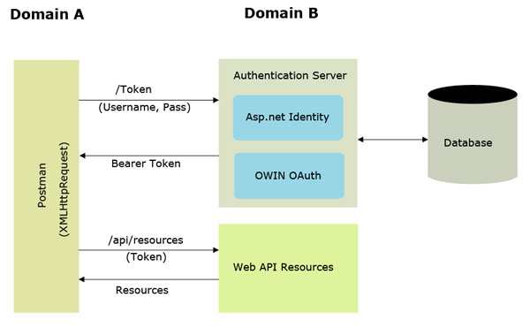

Framework Sample
Framework.Data
ATTENTION: The code exhibited can be generated automatically using the Framework CodeBuilder Tool
Windows Forms UI;
/// <summary>
/// Sets the SQL Server database that is going to be used to retrieve/store data
/// </summary>
/// <returns>IDatabaseManager</returns>
private IDatabaseManager GetDM()
{
var Connection = this.GetAppSettings("FRAMEWORK_DATABASE_CONNECTION");

container.databaseManager = container.connectionManager.Configure(Connection);

return container.databaseManager;
}

private void btnSample_Click(object sender, EventArgs e)
{
using (var DM = GetDM())
{
using (var BLL = new UserBLL(container))
{
var oUser = BLL.SearchByID(1);

if(DM.HasError)
{
MessageBox.Show(DM.ErrorMessage);
}
else
{
MessageBox.Show(oUser.Name);
}

}
}
}

BLL Layer:
/// <summary>
/// Search the user based on its identification
/// </summary>
public UserBES SearchByID(int UserID)
{
return DAL.SearchByID(UserID);
}
DAL Layer:
/// <summary>
/// Search the user based on its identification
/// </summary>
public UserBES SearchByID(int UserID)
{
db.Run("USP_USER_BY_ID");

db.In("ID_USER", UserID);

return db.Map<UserBES>();

}

BES Layer (Model):

/// <summary>
/// User model class
/// </summary>
[Serializable]
public sealed class UserBES : BusinessEntityStructure
{
#region| Properties

/// <summary>
/// User identified
/// </summary>
public int ID { get; set; }

/// <summary>
/// Username
/// </summary>
public string Name { get; set; }

/// <summary>
/// Email address
/// </summary>
public string Email { get; set; }

#endregion

#region| Constructor

public UserBES()
{
this.Map("ID");
this.Map("NM_USER", "Name");
this.Map("DS_MAIL","Email");
}

#endregion
}

Framework – Web.Config/App.Config Setup

<appSettings>

<!-- FRAMEWORK: BEGIN -->

<add key="DB_CONN_KEY" value="DB_DEV"/>
<!-- Database connection key use to easily change the database environment -->

<add key="DB_DEV" value="[ENCRYPTED_STRING]"/>
<add key="DB_UAT" value="[ENCRYPTED_STRING]"/>
<add key="DB_PRD" value="[ENCRYPTED_STRING]"/>
<!-- Database connection string encrypted using TripleDESProtectedConfigurationProvider -->

<add key="FRAMEWORK_PROFILE_ENABLED" value="true"/>
<!-- Indicates whether the data profiler is enabled C:\FRAMEWORK_PROFILER_LOG.txt -->

<add key="FRAMEWORK_COMMAND_TIMEOUT" value="2"/>
<!-- The time in seconds to wait for the command to execute -->

<add key="FRAMEWORK_CONNECTION_TIMEOUT" value="2"/>
<!-- The time in seconds to wait for a connection to the server -->

<add key="FRAMEWORK_RAISE_EXCEPTION" value="true"/>
<!-- Indicates whether the exceptions must be thrown -->

<!-- FRAMEWORK: END-->

</appSettings>

Framework Data Profiler
When you set the “FRAMEWORK_PROFILE_ENABLED” to “true” in the web.config, the Framework.Data layer will store all T-SQL statements that are going to be executed in the database in a plain text file. This option is much better than attaching a SQL Profile in a SQL Server to do the same operation, especially in a production environment. The content will be appended into a File at the following path “C:\FRAMEWORK_DATA_PROFILER_LOG.txt”.

Debug / Release
Don’t forget: Before publishing an application in the production environment, ALWAYS changes the “debug” attribute to "false" in the config file and ALWAYS compiles the version as RELEASE.
<compilation debug="false" targetFramework="4.0" />

MARS – Multiple Active Result Sets
Always use stored procedure with multiple result sets (MARS) whenever possible, optimizing the application and the database performance.
In following example, using only one round-trip to the underlying database, the Framework fills the order class and the Products and Payments properties (sub-classes) as well.
public OrderBES FindByOrderID(string OrderNumber)
{
this.Procedure("USP_ORDER_BY_ID_S");
In("ID", OrderNumber);
var output = new OrderBES();
using (var oReader = GetReader())
{
if(oReader.IsNotNull())
{
oPedido = db.Mapper.Map< OrderBES>(oReader , true);
// Order Products
if (Reader.NextResult())
{
oPedido.Products = db.Mapper.GetList<ProductBES>(oReader , true);
}
// Order payments options
if (Reader.NextResult())
{
oPedido.Payments = db.Mapper.GetList<PaymentBES>(oReader);
}
}
}
return output;
}

Table-Valued Parameters
Table-valued parameters provide an easy way to marshal multiple rows of data from a client application to SQL Server without requiring multiple round trips or special server-side logic for processing the data. You can use table-valued parameters to encapsulate rows of data in a client application and send the data to the server in a single parameterized command. The incoming data rows are stored in a table variable that can then be operated on by using Transact-SQL.
See below how simple is the Table Value Parameter implementation:
All we need to do is create a Table Value Parameter type and then a new Stored Procedure with a parameter whose datatype is the same as you have just created. In the example below we have a parameter named “@TVP_PRODUCT“.
CREATE TYPE TVP_PRODUCT AS TABLE
(
CD_PRODUCT CHAR(6),
QTD_PRODUCT INT
);
GO
CREATE PROCEDURE USP_PRODUCTS_I
(
@TVP_PRODUCT TVP_PRODUCT
)
AS
INSERT INTO TB_PRODUCT
SELECT * FROM @TVP_PRODUCT
GO
Afterwards, In the BLL layer we need to create a DataTable to store the data that will be passed to the parameter that is a Table Value Parameter.
public void SaveProducts(string[] Itens)
{
DataTable oDataTable = new DataTable("TVP_PRODUCT");
oDataTable.Columns.Add("CD_PRODUCT", typeof(string));
oDataTable.Columns.Add("QTD_PRODUCT", typeof(Int32));
for (int i = 0; i < Itens.Length - 1; i++)
{
oDataTable .Rows.Add(Itens[i].Substring(0, 6), 10);
}
return DAL.SaveProducts(oDataTable);
}
And finally, in the DAL layer just use the incoming DataTable from BLL Layer and setup the parameter value accordingly to its corresponding value.
public void SaveProducts(DataTable dataTable)
{
this.Procedure("USP_PRODUCTS_I");
In("TVP_PRODUCT", dataTable);
this.Execute();
}

Switch among environments
From now onward, let’s use the “DB_CONN_KEY” value in the appSettings node of the web.config/app.config file to set the current connection string that our application will use.

XML in SQL Server 2000/2005
Here is an example of using XML to handle multiple records in SQL Server to avoid multiple database server access.
Procedure that receives a parameter that contains XML string:
CREATE PROCEDURE USP_PRODUCTS_XML_I
(
@XML TEXT
)
AS
SET NOCOUNT ON

DECLARE @IDOC int
DECLARE @ROWID INT

--Create an internal representation of the XML document.
EXEC SP_XML_PREPAREDOCUMENT @IDOC OUTPUT, @XMLDOC

INSERT INTO TB_ORDER_ITEMS
SELECT ID, PRODUTO
FROM OPENXML(@IDOC, 'ROOT/PRODUCT', 1)
WITH
(
ID INT,
PRODUCT CHAR(6)
)

-- Removes the internal representation of the XML document
EXEC SP_XML_REMOVEDOCUMENT @IDOC

GO
Method that generates the XML to be sent as a parameter to the Procedure:
public string GetProductsXML(QuoteBES quote)
{
var oSB = new StringBuilder();
oSB.Append("<?xml version=\"1.0\" encoding=\"iso-8859-1\" ?>");
oSB.Append("<ROOT>");
foreach (var oProduto in quote.Products)
{ oSB.Append("<PRODUCT ID=\"" + Counter.ToString() + "\" CODE=\"" + ProdutoI.Code + "\" />");
}
oSB.Append("</ROOT>");
return oSB.ToString();
}

Solid

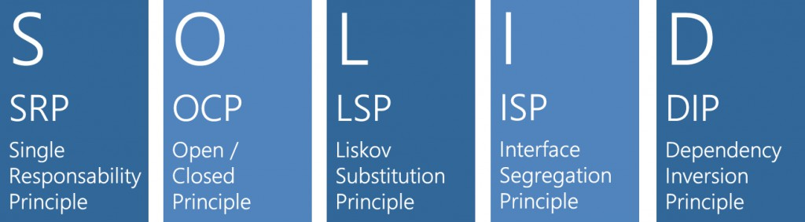
Nowadays, one of the biggest struggles that developers have with adopting Unit Testing, whether it’s Test Driven Development (TDD), Behavior Driven Development (BDD) or even just Test Eventual Development (TED), is the difficulty some code is to test. This is typically when code doesn’t follow the SOLID design principles. If you aren’t familiar with Robert C. Martin’s SOLID Principles, here is a quick definition.
There are five SOLID principles put forth by Robert (Uncle Bob) C. Martin:

Single Responsibility Principle
A class should have one, and only one, reason to change

Open Closed Principle
A module should be open for extension but closed for modification

Liskov Substitution Principle
Subclasses should be substitutable for their base classes

Interface Segregation Principle
Many client specific interfaces are better than one general purpose interface

Dependency Inversion Principle
Depend upon Abstractions. Do not depend on concretions

Web.Config with ProtectedConfigurationProvider
Protected configuration enables you to encrypt sections of an ASP.NET application's Web.config file in order to protect sensitive information used by the application. This can improve the security of your application by making it difficult for an attacker to gain access to the sensitive information even if an attacker gains access to your Web.config file. ASP.NET includes two protected configuration providers that can be used to encrypt sections of a Web.config file: RsaProtectedConfigurationProvider, which uses the RSACryptoServiceProvider to encrypt configuration sections, and DpapiProtectedConfigurationProvider, which uses the Windows Data Protection API (DPAPI) to encrypt configuration sections.
http://netcoders.com.br/criando-web-config-seguros-com-protectedconfigurationprovider/

<configProtectedData>
<providers>
<add name="TripleDESProtectedConfigurationProvider" type="CriptoProtectedConfigurationProvider.TripleDESProtectedConfigurationProvider, CriptoProtectedConfigurationProvider" />
</providers>
</configProtectedData>
<connectionStrings configProtectionProvider="TripleDESProtectedConfigurationProvider">
<EncryptedData></EncryptedData>
</connectionStrings>

SOLID - Dependency Injection
There are several benefits from using dependency injection containers rather than having components satisfy their own dependencies. Some of these benefits are:
- Reduced Dependencies
- Reduced Dependency Carrying
- More Reusable Code
- More Testable Code
- More Readable Code
Thus, developers must use dependency injection in the company’s applications regardless the project type. The most commons developer injection are: Microsoft Unity, NInject, Autofac.
Developer's Guide to Dependency Injection Using Microsoft Unity
https://msdn.microsoft.com/en-us/library/dn223671(v=pandp.30).aspx
NInject
https://github.com/ninject/ninject/wiki
http://www.ninject.org/
AutoFAC
https://autofac.org/

Recomendations

- Always use the available services that the Framework provides such (Database, IO, Message Queue, Logging, Web, Security, ADSI, etc.);
- Never use DataSets, DataTables, DataReaders data directly in your application, instead use POCO classes;
- Avoid the Try/Catch usage, only use that when you don’t have control about the code. If you really need to do that, never throw an exception whose content is null except if you are in a component whose argument is really required for business purposes;
- Whenever possible use StringBuilder to perform string concatenation of large amount of data;
- Don’t call the GC.Collect() method, cause it may cause performance bottleneck; Only use this method when strictly required;
- Use the Lock keyword while working with threads that share a common object;
- Do never Rethrow an exception using “throw e” because it will not retain the inner exception and the CallStack information that give us further details about the error;
- Group all the namespaces based on its type. Example:
using System;
using System.Collections.Generic;
using System.Windows.Forms;
using Framework.CodeBuilder;
using Framework.Data;

References
http://msdn.microsoft.com/en-us/library/ms229042.aspx
https://msdn.microsoft.com/en-us/library/x2dbyw72(v=vs.71).aspx
https://msdn.microsoft.com/en-us/library/wfc2t3az.aspx

